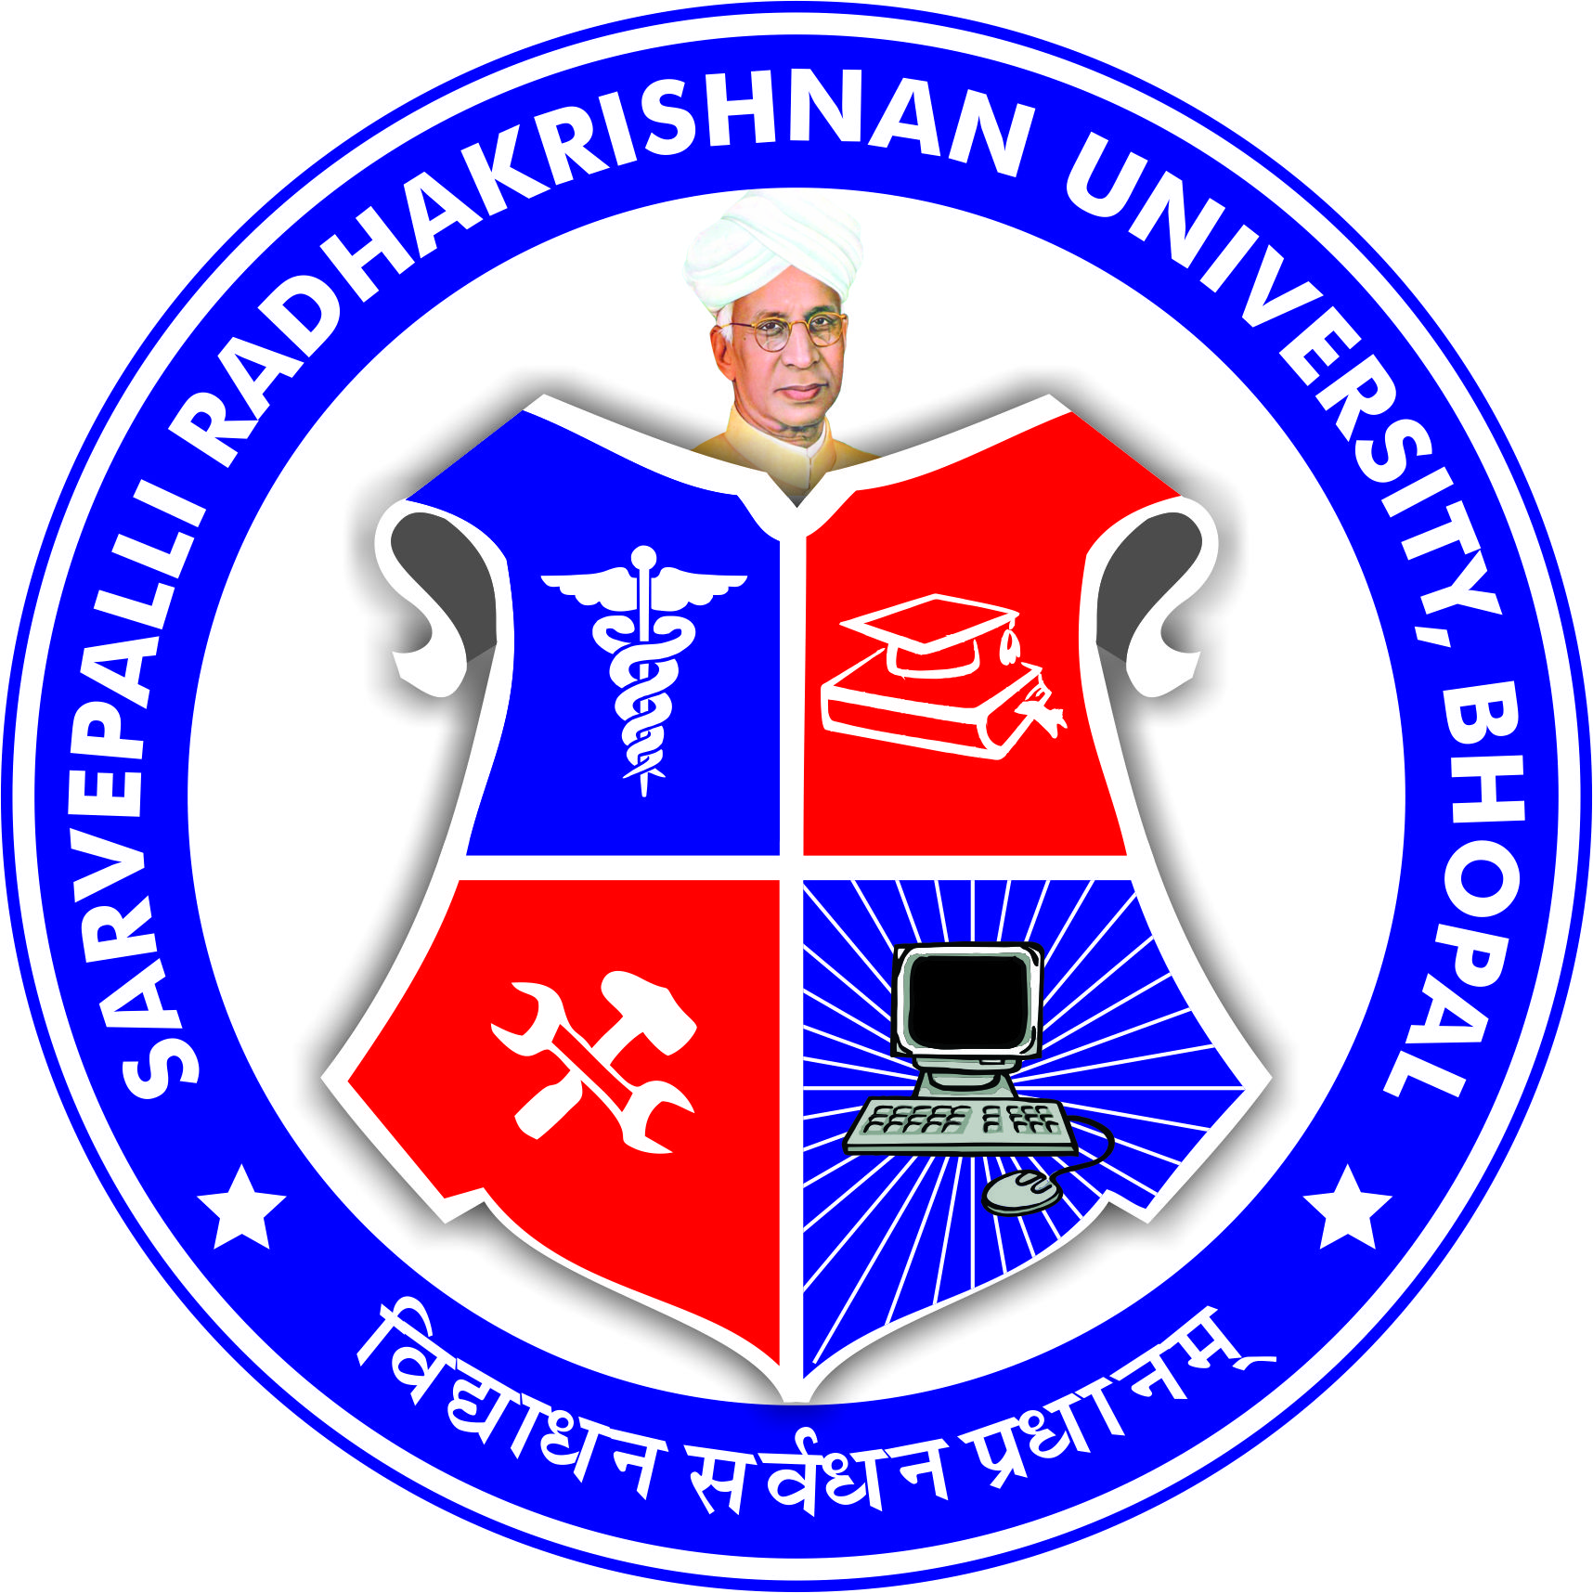
SARVEPALLI RADHAKRISHNAN UNIVERSITY
NH 12,RKDF IST CAMPUS, HOSHANGABAD ROAD, MISROD, BHOPAL (M.P.)
¼Statutory University established by Govt. of M.P. under section 2(F½ of UGC act)
Website: www.srku.edu.in, E-mail: info@srku.edu.in/srkubhopal@gmail.com
Phone: 0755-4700981 Fax: 07554700981

NO. DATE
Women Grievance Committee
Order
Women Grievance committee of Sarvepalli Radhakrishnan University is here by reconstituted as below:
- Dr. Archana Selvan Chairman 9302255469
- Dr. Namrata Jain Member 9406567249
- Dr. Aparna Paliwal Member 8305574932
- Ms. Antim Vora Member 8329484162
- Dr. Bharti Chaurasia Secretary 7974498943
- Dr. Bhavika Bhavsar Member 9998013300
- Ms. Kajal Kumari Student Rep 07061307206
(3rd year EE)

- Ms. Itika Panwar Student Rep 9068040188
(3rd Year Engg.)

Registrar

Note-Secretary of the committee shall be responsible for conducting meetings & maintaining minutes of meeting.

